Swiggy project

--- KPI's

-- total orders

SELECT COUNT(*) AS total_orders
FROM Swiggy_orders

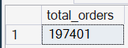

-- total revenue

SELECT FORMAT(SUM (CONVERT(FLOAT, Price_INR ))/1000000,'N2')+ ' M MILLION'
AS total_revenue
FROM Swiggy_orders

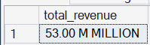

--- Avg dish price N2 Means after decimal place value

SELECT FORMAT (AVG (CONVERT(FLOAT, Price_INR )),'N2')+ 'INR' AS avg_dish_price
FROM Swiggy_orders

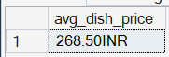
-- Date based analysis

--- Monthly order analysis

SELECT
d.Year,
d.MONTH,
d.Month_name,
COUNT(*) AS total_orders
FROM Swiggy_orders f
JOIN date_table d
ON f.date_id= d.date_id
GROUP BY
d.Year,
d.Month,
d.Month_Name
ORDER BY COUNT(*) DESC

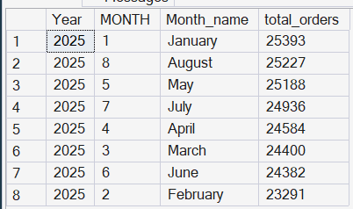

-- monthly order sales

SELECT
d.Year,
d.Month,
d.Month_name,
FORMAT (SUM( CONVERT( FLOAT, Price_INR))/1000000, 'N2')+'M' AS total_revenue
FROM Swiggy_orders f
JOIN date_table d
ON f.date_id= d.date_id
GROUP BY
d.Year, d.Month,d.Month_Name
ORDER BY SUM(Price_INR) DESC

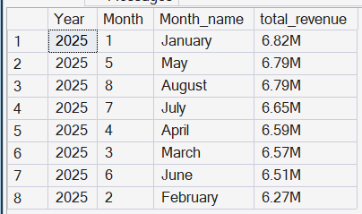

-- Quarterly order analysis

SELECT
d.Year,
d.quarter,
COUNT(*) AS total_orders
FROM Swiggy_orders f
JOIN date_table d
ON f.date_id= d.date_id
GROUP BY
d.Year,
d.quarter
ORDER BY COUNT(*) DESC

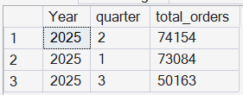

--yearly order analysis

SELECT
d.Year,
COUNT(*) AS total_orders
FROM Swiggy_orders f
JOIN date_table d
ON f.date_id= d.date_id
GROUP BY
d.Year
ORDER BY COUNT(*) DESC

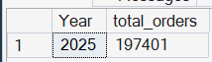

-- week days analysis

SELECT
DATENAME(WEEKDAY, d.full_date) AS Day_name,
COUNT(*) AS Total_orders
FROM Swiggy_orders f
JOIN date_table d
ON f.date_id = d.date_id
GROUP BY DATENAME(WEEKDAY, d.Full_date),DATEPART(WEEKDAY, d.Full_date)
ORDER BY DATEPART(WEEKDAY, d.Full_date)

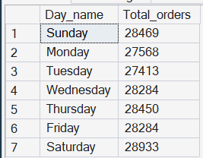

-- Top 10 cities by order

SELECT TOP 10
l.City,
COUNT(*) AS Total_orders
FROM Swiggy_orders f
JOIN location_table l
ON l.location_id = f.Location_id
GROUP BY l.city
ORDER BY COUNT(*) DESC;

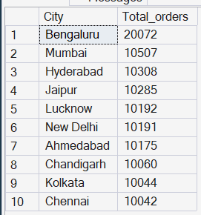

-- Bottom 5 cities order

SELECT TOP 5
l.City,
COUNT(*) AS Total_orders
FROM Swiggy_orders f
JOIN location_table l
ON l.location_id = f.Location_id
GROUP BY l.city
ORDER BY COUNT(*) ASC;

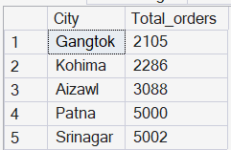

----Revenue contribution by state

select
l.state,
format(sum(convert(float,f.price_inr))/1000000,'N2')+'M' AS TOTAL_REVENUE FROM SWIGGY_ORDERS F
JOIN LOCATION_TABLE L
ON L.LOCATION_ID= F.LOCATION_ID
GROUP BY L.STATE
ORDER BY SUM(F.PRICE_INR)DESC;

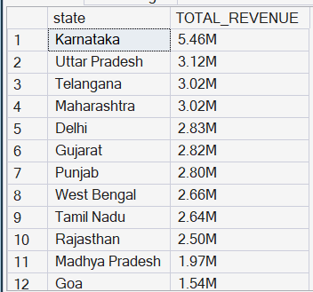

---TOP 10 Restaurant by order

SELECT TOP 10
R.RESTAURANT_NAME,
COUNT(*) AS TOTAL_ORDER_BY_RESTAURANT FROM SWIGGY_ORDERS F
JOIN RESTAURANT_TABLE R
ON R.RESTAURANT_ID=F.RESTAURANT_ID
GROUP BY R .Restaurant_name
ORDER BY COUNT(*) DESC

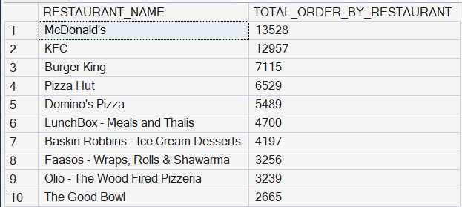

--TOP CATEGORYIES BY ORDER
SELECT
C.CATEGORY,
COUNT(*) AS TOTAL_ORDERS FROM SWIGGY_ORDERS F
JOIN CATEGORY_TABLE C
ON C.CATEGORY_ID=F.CATEGORY_ID
GROUP BY C.CATEGORY
ORDER BY COUNT(*) DESC;

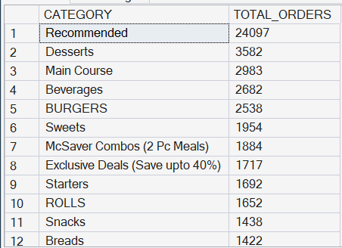

------MOST ORDERS DISHES

SELECT TOP 10
D.DISH_NAME,
COUNT(*)AS TOTAL_ORDERS FROM SWIGGY_ORDERS F
JOIN Dish_table D
ON D.DISH_ID=F.DISH_ID
GROUP BY D.DISH_NAME
ORDER BY COUNT(*) DESC;

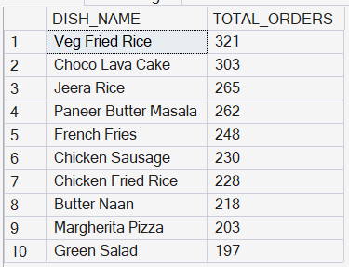

--Category-wise Order and Average Rating Analysis

SELECT
C.CATEGORY,
COUNT(*) TOTAL_ORDER,
AVG(F.RATING)AS ORDER_RATING
FROM SWIGGY_ORDERS F
JOIN CATEGORY_TABLE C
ON F.CATEGORY_ID=F.CATEGORY_ID
GROUP BY C.CATEGORY
ORDER BY COUNT(*) DESC;

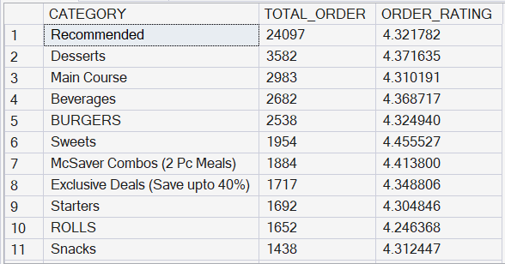
---PRICE RANGE ORDER

SELECT
CASE
WHEN CONVERT (FLOAT,PRICE_INR)<100 THEN 'Under 100'
WHEN CONVERT(FLOAT,PRICE_INR)BETWEEN 100 AND 199 THEN '100-199'
WHEN CONVERT(FLOAT,PRICE_INR)BETWEEN 200 AND 299 THEN '200-299'
WHEN CONVERT (FLOAT,PRICE_INR) BETWEEN 300 AND 399 THEN '300-399'
WHEN CONVERT(FLOAT,PRICE_INR)BETWEEN 400 AND 499 THEN '400-499'
ELSE '500+'
END AS PRICE_RANGE,
COUNT(*) AS TOTAL_ORDERS
FROM SWIGGY_ORDERS
GROUP BY
CASE
WHEN CONVERT (FLOAT,PRICE_INR)<100 THEN 'Under 100'
WHEN CONVERT(FLOAT,PRICE_INR)BETWEEN 100 AND 199 THEN '100-199'
WHEN CONVERT(FLOAT,PRICE_INR)BETWEEN 200 AND 299 THEN '200-299'
WHEN CONVERT (FLOAT,PRICE_INR) BETWEEN 300 AND 399 THEN '300-399'
WHEN CONVERT(FLOAT,PRICE_INR)BETWEEN 400 AND 499 THEN '400-499'
ELSE '500+'
END
ORDER BY TOTAL_ORDERS DESC



